Linux Programming: Assignment-9:

- Write a shell script using if…else to check if a number is even or odd.
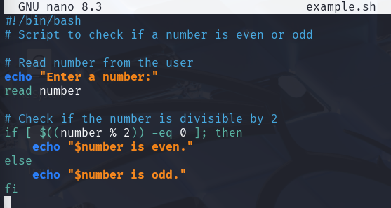

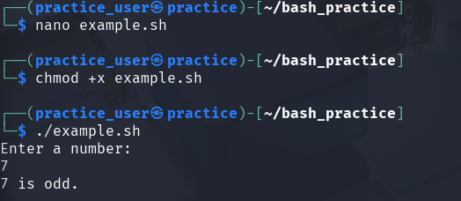

- Explain the difference between if and case statements in bash.
- if statement:

- Used to test conditions (like numbers, strings, file existence, etc.)
- Can handle complex logical expressions using && (and), || (or).

- case statement:
- Used to match a variable against multiple patterns
- Cleaner and easier when you have many specific values to check
- Works like a switch-case in other programming languages.

- Write a script to find the largest of three numbers entered by the user.
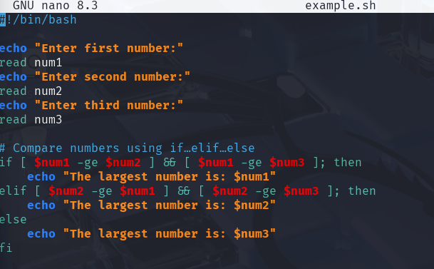

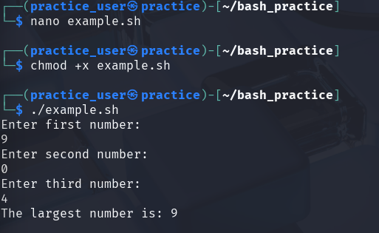
- How do you use a for loop to traverse an array in bash? Give an example. The array is defined as arr=(123, “Abs”, -2.3, ‘A’, 23.56, 0).
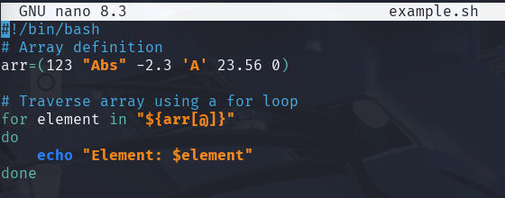

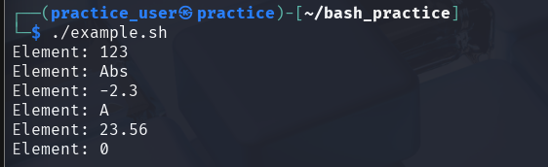

- Write a shell script to loop through all files in the current directory and display their names.
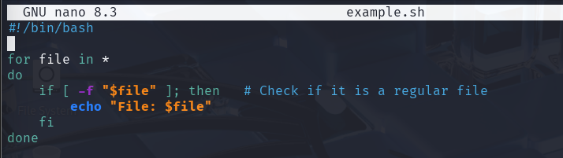
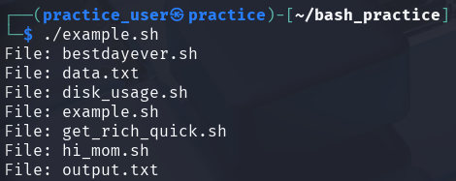

- What is the difference between while and until loops in bash?
- while loop:
- Executes the loop as long as the condition is true.
- Condition is checked before each iteration.
- Use it when you want the loop to repeat while something is true.
- until loop:
- Executes the loop as long as the condition is false.
- Condition is checked before each iteration.
- Use it when you want the loop to repeat until something becomes true

- Write a countdown timer script using a while loop.
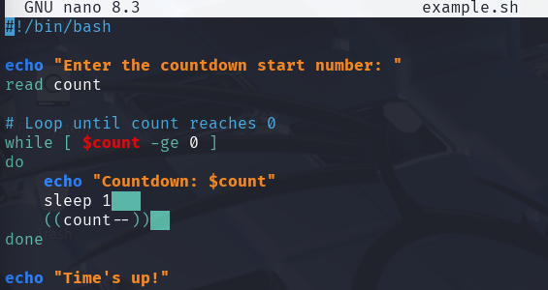

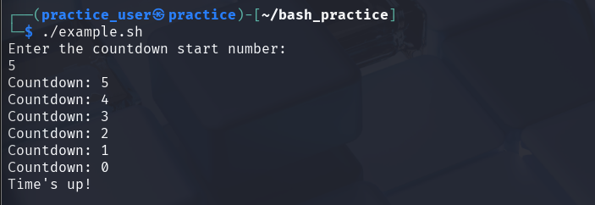

- How do you use break and continue statements in loops? Give examples.
- break :
#!/bin/bash
for i in {1..5}
do
if [ $i -eq 3 ]; then
echo "Breaking the loop at $i"
break
fi
echo "Number: $i"
done
#THIS WILL BREAK THE LOOP AT 3 AND THE ITERATION WILL STOP.

- continue :
#!/bin/bash
for i in {1..5}
do
if [ $i -eq 3 ]; then
echo "Skipping $i"
continue
fi
echo "Number: $i"
done
#THE LOOP WILL SKIP THE ACTION FOR i=3 AND WILL CONTINUE WITH THE OTHER NUMBERS.

- Write a script to check if a file exists or not using the if and else loop.

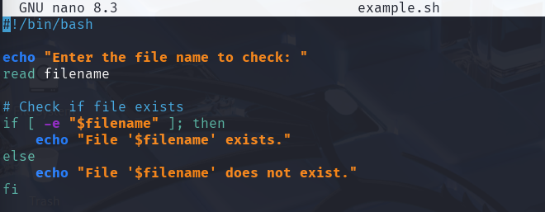

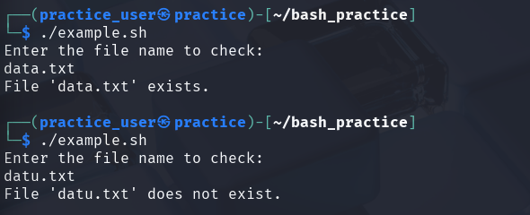

- Write a script to calculate factorial of a number using for loop.
- 